Design Document-Assignment-4
Areen Patil – IMT2023013
UML Diagram:
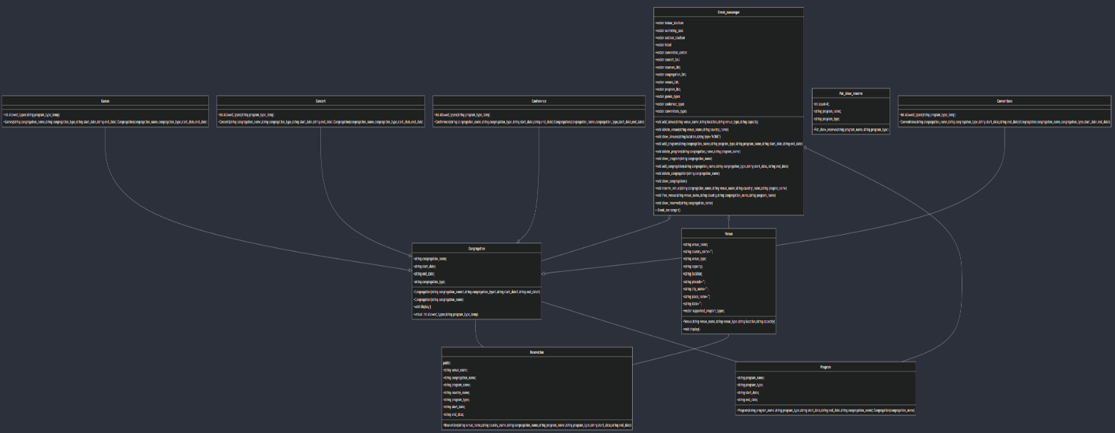
3 UML Class Diagram Relations
- Congregation o-- Reservation: A congregation can have multiple reservations.
- Program o-- Congregation: A program is associated with a congregation.
- Reservation o-- Venue: A reservation is linked to a specific venue.
- Venue o-- Reservation: A venue can have multiple reservations.
- Congregation o-- Venue: Congregations can be held in different venues.
- Reservation -- Venue: A reservation is made for a specific venue.
- Reservation -- Congregation: A reservation is associated with a congregation.
- Congregation o-- * Venue: A congregation is held at a venue.
- Program -- Congregation: A program is associated with a congregation.
- Venue -- Program: A venue supports specific types of programs.
Classes:
1.Reservation
- Purpose: Represents a reservation for a program at a venue.
- Attributes:
  - string venue_name: Name of the venue where the reservation is made.
  - string congregation_name: Name of the congregation associated with the reservation.
  - string program_name: Name of the program being reserved.
  - string country_name: Country where the venue is located.
  - string program_type: Type of the program.
  - string start_date: Start date of the program.
  - string end_date: End date of the program.
- Constructor: Initializes all attributes with given values.
2.Congregation
- Purpose: Base class for different types of congregations.
- Attributes:
  - string congregation_name: Name of the congregation.
  - string start_date: Start date of the congregation event.
  - string end_date: End date of the congregation event.
  - string congregation_type: Type of the congregation (e.g., Games, Concert, etc.).
- Constructors:
  - Takes congregation_name, congregation_type, start_date, and end_date.
  - Takes only congregation_name.
- Methods:
  - void display(): Prints the details of the congregation.
  - virtual int allowed_types(string program_type_temp): Determines if a given program type is allowed (to be overridden by derived classes).
3.Games, Concert, Conference, Conventions (Derived from Congregation)
- Purpose: Represent specific types of congregations, each with different allowed program types.
- Methods:
  - int allowed_types(string program_type_temp): Checks if the program type is allowed for the specific congregation type (implemented with specific allowed types).
- Attributes:
  - string program_name: Name of the program.
  - string program_type: Type of the program.
  - string start_date: Start date of the program.
  - string end_date: End date of the program.
- Constructor: Initializes attributes with given values and calls the base class constructor with congregation_name.
4.Venue
- Purpose: Represents a venue where events and programs can be held.
- Attributes:
  - string venue_name: Name of the venue; string country_name: Country where the venue is located; string venue_type: Type of the venue (e.g., Indoor Stadium, Swimming Pool); string capacity: Capacity of the venue;string location: Full location of the venue, which includes place, city, state, pincode, and country.
- Constructor: Parses location to extract details like place, city, state, pincode, and country.
- Methods:
  - void display(): Prints the details of the venue.
5.For_show_reserve
- Purpose: Supports additional functionality for showing reservations.
- Attributes:
  - int count: Counter for the number of reservations.
  - string program_name: Name of the program.
  - string program_type: Type of the program.
- Constructor: Initializes program_name and program_type.
6.Class Name: Event_manager
- Provides functionalities to add, delete, and display venues, programs, and congregations.
- Handles reservations and checks for valid program dates.
2. Class Attributes
- Vectors for Venue Types:
  - indoor_stadium - Types of programs allowed in indoor stadiums.
  - swimming_pool - Types of programs allowed in swimming pools.
  - outdoor_stadium - Types of programs allowed in outdoor stadiums.
  - Hotel - Types of programs allowed in hotels.
  - convention_center - Types of programs allowed in convention centers.
  - concert_hall - Types of programs allowed in concert halls.
- Vectors for Storage:
  - reserves_list - Stores all reservations.
  - congregation_list - Stores pointers to all congregations.
  - venues_list - Stores all added venues.
  - program_list - Stores all programs.
3. Class Methods
- add_Venue(string venue_name, string location, string venue_type, string capacity)
  - Description: Adds a new venue to the venues_list.
  - Parameters:
    - venue_name: Name of the venue ; location: Location of the venue (formatted as a string) ; venue_type: Type of the venue ; capacity: Capacity of the venue.
- delete_venue(string venue_name, string country_name)
  - Description: Deletes a venue from the venues_list if it matches the given name and country.
  - Parameters:
    - venue_name: Name of the venue to delete ; country_name: Country where the venue is located.
- show_Venues(string location, string type = "NONE")
  - Description: Displays venues based on location and optional venue type.
- add_program(string congregation_name, string program_type, string program_name, string start_date, string end_date)
  - Description: Adds a new program to the program_list if it meets the criteria for the specified congregation.
  - Parameters: congregation_name: Name of the congregation ; program_type: Type of the program ; program_name: Name of the program ; start_date: Start date of the program ; end_date: End date of the program.
- delete_program(string congregation_name, string program_name)
  - Description: Deletes a program from the program_list if it matches the given congregation and program names.
- show_program(string congregation_name)
  - Description: Displays programs associated with the specified congregation.
  - Parameters:
    - congregation_name: Name of the congregation.
- add_congregation(string congregation_name, string congregation_type, string start_date, string end_date)
  - Description: Adds a new congregation based on type and date range.
  - Parameters:
    - congregation_name: Name of the congregation ; congregation_type: Type of the congregation ; start_date and end_date: Start and end date of the congregation.
- delete_congregation(string congregation_name)
  - Description: Deletes a congregation from the congregation_list if it matches the given name.
  - Parameters:
    - congregation_name: Name of the congregation to delete.
- show_congregation()
  - Description: Displays all congregations in the congregation_list.
- void reserve_venue(string congregation_name, string venue_name, string country_name, string progran_name)
  - Parameters:
    - congregation_name: Name of the congregation.
    - venue_name: Name of the venue.
    - country_name: Country where the venue is located.
    - progran_name: Name of the program to be reserved.
  - Details:
    - Checks if the venue, congregation, and program exist and verifies the program type then checks for the dates collision.
    - Adds the reservation to reserves_list if all checks pass and -1 for error.
- void free_venue(string venue_name, string country, string congregation_name, string program_name)
  - Parameters:
    - venue_name: Name of the venue.
    - country: Country where the venue is located.
    - congregation_name: Name of the congregation.
    - program_name: Name of the program.
  - Details:
    - Finds and deletes the reservation from reserves_list if it exists.
    - Prints error messages and returns -1 if no matching reservation is found.
3.3. Show Reserved Programs
- void show_reserved(string congregation_name)
  - Description: Displays all reserved programs for a given congregation, including program counts and venue details.
  - Parameters:
    - congregation_name: Name of the congregation to display reserved programs for.
  - Details:
    - Checks if the congregation exists.
    - Collects and counts programs from program_list and reserves_list.
    - Prints details of each program and associated venues.
    - Prints error messages and returns -1 if the congregation does not exist.
3.4. Destructor
- ~Event_manager()
  - Description: Cleans up dynamically allocated memory for congregations.
  - Returns: void
  - Deletes all Congregation objects pointed to by congregation_list.
Functions:
1. date_compare(string date1, string date2)
- Purpose: Compares two dates.
- Returns: 1 if the date1 is greater, 2 if the date2 is greater and 0 if the dates are equa.

2. date_comparator(string congregation_start_date, string congregation_end_date, string program_start_date, string program_end_date)
- Purpose: Checks if the program's dates fall within the congregation's dates.
- Returns: 1 if they are and -1 if they are not.
Function Name: main
Purpose:
- Parses command-line arguments to optionally read input from a file or standard input and call the commands.
- Manages congregations, programs, venues, and reservations using the Event_manager class.
Command-Line Argument Handling:
- Parameters:
  - argc: Argument count.
  - argv: Argument vector containing command-line arguments.
- Operations:
  - Checks if there is more than one command-line argument.
  - If a filename is provided, attempts to open it using ifstream.
  - If the file cannot be opened, prints an error message and exits with code 1.
  - If no filename is provided, defaults to reading input from stdin using cin.
- Input Source:
  - Uses an istream pointer (input_stream) to read from either ifstream or cin, depending on whether a file was specified.
- Operations:
  - Reads lines from the input using getline.
  - For each line, parses the command using stringstream.
- Commands and Operations:
  - End: Terminates the loop.
  - addCongregation: Validate dates and add the congregation.
  - deleteCongregation: Deletes a congregation by name.
  - showCongregations: Displays all congregations.
  - addProgram: Reads details of a program and adds it to the manager.
  - deleteProgram: Deletes a program by congregation and program name.
  - showPrograms: Displays all programs for a specific congregation.
  - addVenue: Reads details of a venue and adds it to the manager.
  - deleteVenue: Deletes a venue by name and country.
  - showVenues: Displays venues based on location and optionally venue type.
  - reserveVenue: Reads details for a reservation and reserves the venue.
  - freeVenue: Frees up a venue by removing the reservation.
  - showReserved: Displays all reservations for a specific congregation.
- Date Validation:
  - When dates are invalid (e.g., end date before start date), prints an error message and continues to the next command.

